Software Requirements Specification

Version 1.0

<<Annotated Version>>

November 1, 2020

Utility Android Application

Mason Mullins

Brandon Tate

Brandon Young

Submitted in partial fulfillment

Of the requirements of

CS 310 Software Engineering

<<Any comments inside double brackets such as these are not part of this SRS but are

comments upon this SRS example to help the reader understand the point being made.

Refer to the SRS Template for details on the purpose and rules for each section of this

document.>>

# 

1.0. Introduction **4**

1.1. Purpose 4

1.2. Scope of Project 4

1.3. Glossary 5

1.4. References 5

1.5. Overview of Document 6

2.0 Overall description **7**

2.1 System Environment **7**

2.2 Functional Requirements Specification **8**

2.2.1 Reporter Use Case 8

Use Case: Reporting an Outage 8

Use Case: Checking on Status of Reported Outage 9

Use Case: Updating Reported Outage 9

2.2.2 Consumer Use Case 10

Use Case: Viewing of Outages 10

2.2.3 Vendor Use Case 11

Use Case: Receiving a New Outage Report 11

Use Case: Viewing of an Outage Report 11

Use Case: Editing of a Outage Report 12

Use Case: Closing of a Open/Urgent Outage Report 13

Use Case: Reopening of a Closed Outage Report 14

Use Case: Changing the Urgency of a Outage Report 15

3.0 Requirements Specification **16**

3.1 External Interface Requirements **16**

3.2 Functional Requirements **16**

3.2.1 Report outage 16

3.2.2 Alert vendor for outage 16

3.2.3 Search for a location 16

### 1.0. Introduction

#### ***1.1. Purpose***

The purpose of this document is to present a detailed description of the Android Application for Utility Outage. It will explain the purpose and features of the system, the interfaces

of the system, what the system will do, the constraints under which it must operate and

how the system will react to external stimuli. This document is intended for both the

stakeholders and the developers of the system and will be proposed to the **[Who are we proposing this document to?]** for its approval.

#### ***1.2. Scope of Project***

This Android Application will provide notifications to users of local utility outages in the region. Users will be able to report local outages on their phone via Google Maps API. Other users in the area will start to receive a notification once a certain threshold has been met for local reporting. This will also be targeted to utility workers in order to produce a faster response time to resolve outages. More specifically, users can report utility problems on their smartphones and the application will facilitate communication between users via Android notification or email. Once a certain threshold has been met, then users in the area will receive notifications about the reportage outage. The Vendor will be able to follow up on Outage Reports that have been submitted by a Reporter. Reporter users will be able to view updates made to their Outage Report from the Vendor as well as respond. Consumer users will have the ability to view Open Outage Reports in their area that have been created by the Reporter user.

#### ***1.3. Glossary***

|  |  |
| --- | --- |
| **Term** | **Definition** |
| Outage Report | The document that is tracked by the system; These reports are created by Reporters. These reports can be viewed by all users. |
| Reporter | Person submitting an Outage Report to be reviewed. |
| Database | Collection of all the information monitored by this system. |
| Vendor | Person who receives Outage Reports to follow up on, responds to Outage Reports directly, and makes final judgments for closing reports. |
| Field | A cell within a form. |
| Consumer | Person who is able to view all open Outage Reports. Someone visiting to read Outage Reports |
| Review | A written recommendation about the appropriateness of an article for publication; may include suggestions for improvement. |
| Reviewer | A person that examines an article and has the ability to close, open, comment, and update the urgency of an Outage Report. This refers to a Vendor user. |
| Software Requirements Specification | A document that completely describes all of the functions of a proposed system and the constraints under which it must operate. For example, this document. |
| Stakeholder | Any person with an interest in the project who is not a developer. |
| User | Vendor, Consumer, or Reporter |

#### ***1.4. References***

IEEE. *IEEE Std 830-1998 IEEE Recommended Practice for Software Requirements Specifications.* IEEE Computer Society, 1998.

#### 1.5. Overview of Document

The next chapter, the Overall Description section, of this document gives an overview of the functionality of the product. It describes the informal requirements and is used to establish a context for the technical requirements specification in the next chapter.

The third chapter, the Requirements Specification section, of this document is written primarily for the developers and describes in technical terms the details of the functionality of the product.

Both sections of the document describe the same software product in its entirety, but are intended for different audiences and thus use different terminology.

### **2.0 Overall description**

### 2.1 System Environment

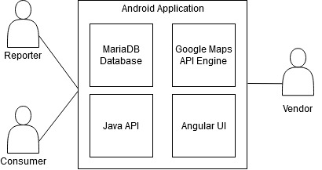

The Utility Outage Android Application has two main users and a cooperating system. The system will be using a SQLite database along with a Java Spring Boot back end. The front end of the application will be Angular. Google Maps API will be used for location services when reporting and viewing outage reports. The Consumer will consist of both a normal user as well as a utility worker. These types of users can report outages in their area. The Consumer will be able to view other reports on the application of outages. The Java API will also have an authentication service layer attached to it. This will be used to authenticate users as well as prevent spamming of outages.

### 2.2 Functional Requirements Specification

This section outlines the use cases for each of the two users in this system. As a note, the ‘Utility Worker’ user can also be both a ‘Consumer’ and ‘Reporter.’

#### 2.2.1 Reporter Use Case

##### Use Case: **Reporting an Outage**

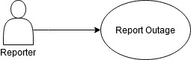

**Brief Description**

The consumer has access to the reports via android application, allowing the user to report an outage.

**Initial Step-By-Step Description**

1. The consumer has confirmed an outage in their area.
2. The consumer will enter in the time of which the outrage occurred in the application, their location (Google Maps API), vendor, etc.
3. The system will display the region’s status via most recent reports.
4. The consumer reads and decides if useful depending on date, location, etc.

##### Use Case: **Checking on Status of Reported Outage**

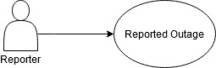

**Brief Description**

The reporter has submitted an outage report, and would like to check the status of their report.

**Initial Step-By-Step Description**

Before this use case can be initiated, the reporter has submitted their Outage Report before they can check the status of it.

1. The reporter has previously submitted an Outage Report.
2. The user logs back into the application.
3. The user finds their previous report and selects to view it.
4. The system will then fetch the report to display the information to the user.

##### Use Case: **Updating Reported Outage**



**Brief Description**

The reporter has submitted an outage report, and would like to update their report. As an example, the Outage could have ceased for a brief period.

**Initial Step-By-Step Description**

Prior to this use case can be initiated, the reporter has submitted their Outage Report before they can check the status of it.

1. The reporter has previously submitted an Outage Report and the report is still in the ‘Open’ state.
2. The user logs back into the application.
3. The user finds their previous report and selects to edit.
4. The user will update their report in the fields that are allowed by the system.
5. The report is saved.
6. The system updates the report.

### 

#### 2.2.2 Consumer Use Case

##### Use Case: **Viewing of Outages**

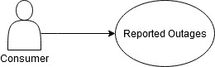

**Brief Description**

The consumer has access to the reports via android application, searching for specific regions to be enlightened.

**Initial Step-By-Step Description**

1. The consumer has confirmed an outage in their area.
2. The consumer will enter in the time of which the outrage occurred in the application, as well as their location (Google Maps API) after being authenticated.
3. The system will display the region’s status via most recent reports.
4. The consumer reads and decides if useful depending on date, location, etc.

#### 

#### 

#### 2.2.3 Vendor Use Case

##### Use Case: **Receiving a New Outage Report**

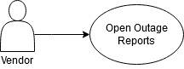

**Brief Description**

The Vendor has access to the reports via android application, searching for specific regions to be enlightened.

**Initial Step-By-Step Description**

1. The vendor has reports of an outage(s).
2. The vendor will review Outage Report(s).
3. The vendor will select the Outage Report to view
4. The system will display the region’s status via most recent reports.
5. The vendor reads and decides if useful depending on date, location, etc.

##### Use Case: **Viewing of an Outage Report**

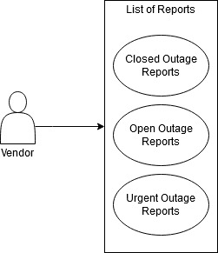

**Brief Description**

The Vendor has access to the reports via android application, searching for specific regions to be enlightened.

**Initial Step-By-Step Description**

1. The vendor navigates to a reports view.
2. The vendor will select the report to view
3. The system will display the region’s status via most recent reports.
4. The vendor reads and decides if useful depending on date, location, etc.

##### Use Case: **Editing of a Outage Report**



**Brief Description**

The Vendor has access to the reports via android application, searching for a specific report to be edited.

**Initial Step-By-Step Description**

1. The vendor navigates to a reports view.
2. The vendor will select the report to edit.
3. The system will display the region’s status via most recent reports as well as other information such as User, Date Submitted, Outage Reported Time, etc.
4. The vendor will edit fields as necessary and save the report.

##### Use Case: **Closing of a Open/Urgent Outage Report**



**Brief Description**

The Vendor has access to the reports via android application, searching for a specific report to be closed.

**Initial Step-By-Step Description**

1. The vendor navigates to either the Open or Urgent Outage Reports view.
2. The vendor will select a report to edit.
3. The system will display the region’s status via most recent reports as well as other information such as User, Date Submitted, Outage Reported Time, etc.
4. The vendor will edit fields as necessary and change the status of the report to ‘Closed’.
5. The vendor saves the report.

##### Use Case: **Reopening of a Closed Outage Report**



**Brief Description**

The Vendor has access to the reports via android application, searching for a specific closed report to be opened.

**Initial Step-By-Step Description**

1. The vendor navigates to ‘Closed Outage Reports’ view.
2. The vendor will select the Closed Report to edit.
3. The system will display the region’s status via most recent reports as well as other information such as User, Date Submitted, Outage Reported Time, etc.
4. The vendor will edit fields as necessary and change the status of the report to ‘Open’.
5. The vendor saves the Closed Report.

##### Use Case: **Changing the Urgency of a Outage Report**



**Brief Description**

The Vendor has access to the reports via android application, searching for a specific report to update the urgency.

**Initial Step-By-Step Description**

1. The vendor navigates to the appropriate report view.
2. The vendor will select a report to edit.
3. The system will display the region’s status via most recent reports as well as other information such as User, Date Submitted, Outage Reported Time, etc.
4. The vendor will edit fields as necessary and change the urgency of the report.
5. The vendor saves the report.

### 3.0 Requirements Specification

### 3.1 External Interface Requirements

This application will be interfaced with Google Maps API. This will allow the application to use location services when an Outage Report will be created, and to attach the location from which the Outage Report came from.

### 3.2 Functional Requirements

The Logical Structure of the Data is contained in Section 3.3.1.

#### 3.2.1 Viewing an Outage Report

|  |  |
| --- | --- |
| **Use Case Name** | Viewing an Outage Report |
| **XRef** | Section 2.2.2 & 2.2.3, Viewing an Outage Report  SDD, Section 7.1 |
| **Trigger** | The Reader assesses the Outage Reports |
| **Precondition** | The Web is displayed with grids for searching |
| **Basic Path** | 1. The User chooses how to search the Web site. The choices are by Author, by Status, by Urgency, and by Created. 2. If the search is by Author, the system creates and presents an alphabetical list of all authors in the database. 3. The User selects an author. 4. The system creates and presents a list of all Outage Reports by that author in the database. 5. The User selects an Outage Report. 6. The system displays the title for the Outage Report. 7. The User selects to view the Outage Report or to return to the article list or to the previous list. |
| **Alternative Paths** | In step 2, if the User selects to search by category, the system creates and presents a list of all categories in the database.   1. The User selects a category. 2. The system creates and presents a list of all Outage Reports in that category in the database. Return to step 5.   In step 2, if the User selects to search by keyword, the system presents a dialog box to enter the keyword or phrase.   1. The User enters a keyword or phrase. 2. The system searches the Abstracts for all Outage Reports with that keyword or phrase and creates and presents a list of all such articles in the database. Return to step 5. |
| **Postcondition** | The selected Outage Report is fetched and displayed to the client machine. |
| **Exception Paths** | The User may abandon the search at any time. |

#### 3.2.2 Creating Outage Report

|  |  |
| --- | --- |
| **Use Case Name** | Creating an Outage Report |
| **XRef** | Section 2.2.1, Creating an Outage Report  SDD, Section 7.1 |
| **Trigger** | The User need to report an outage |
| **Precondition** | The User has experienced an outage |
| **Basic Path** | 1. The User chooses to create an Outage report with the appropriate required information such as Date, Time, Location, Duration, and Urgency. 2. The system then creates the Outage Report to be viewed by the Vendor. 3. The system displays that the Outage Report has been created successfully. 4. The user is returned to their Open Outage Reports page. |
| **Postcondition** | The User is directed to the Open Outage Reports page |
| **Exception Paths** | The User may abandon the creation at any time |

#### 3.2.4 Updating the Urgency of Outage Report

|  |  |
| --- | --- |
| **Use Case Name** | Updating the Urgency of Outage Report |
| **XRef** | Section 2.2.1 & 2.2.3, Updating the Urgency of Outage Report  SDD, Section 7.1 |
| **Trigger** | The User wants to change the urgency of their report |
| **Precondition** | Outage Report has been created and is still open |
| **Basic Path** | 1. The User is on the Open Outage Reports page 2. The User selects the Outage Report that they wish to change the Urgency 3. The User changes the Urgency dropdown 4. The system them updates the Outage Report 5. The User is notified of a successful update of the Outage Report 6. The system displays the Open Outage Reports page for the User. |
| **Postcondition** | The User is directed to the Open Outage Reports page |
| **Exception Paths** | The User may abandon the update at any time. |

#### 3.2.5 Adding Comments to Outage Report

|  |  |
| --- | --- |
| **Use Case Name** | Adding comments to an Outage Report |
| **XRef** | Section 2.2.1 & 2.2.3, Updating the Outage Report  SDD, Section 7.1 |
| **Trigger** | The User wants to add a comment to a report. |
| **Precondition** | Outage Report has been created and is still open |
| **Basic Path** | 1. The User chooses how to search the Web site. The choices are by Author, by Status, by Urgency, and by Created. 2. If the search is by Author, the system creates and presents an alphabetical list of all authors in the database. 3. The User selects an author. 4. The system creates and presents a list of all Outage Reports by that author in the database. 5. The User selects an Outage Report. 6. The system displays the title for the Outage Report. 7. The User selects to view the Outage Report or to return to the article list or to the previous list. 8. The User is then able to leave a comment on the report. 9. The User saves their comment 10. The system updates the Outage Report 11. The system notifies the User that their comment has been posted to the report |
| **Postcondition** | The User is directed to the Report that the comment was left on |
| **Exception Paths** | The User may abandon the update at any time. |

#### 3.2.6 Closing an Outage Report

|  |  |
| --- | --- |
| **Use Case Name** | Closing an Outage Report |
| **XRef** | Section 2.2.3, Closing an Outage Report  SDD, Section 7.1 |
| **Trigger** | The Vendor wants to close the report |
| **Precondition** | Outage Report has been created and is still open |
| **Basic Path** | 1. The Vendor chooses how to search the Web site. The choices are by Author, by Status, by Urgency, and by Created. 2. If the search is by Author, the system creates and presents an alphabetical list of all authors in the database. 3. The Vendor selects an author. 4. The system creates and presents a list of all Outage Reports by that author in the database. 5. The Vendor selects an Outage Report. 6. The system displays the title for the Outage Report. 7. The Vendor selects to view the Outage Report or to return to the article list or to the previous list. 8. The Vendor changes the status of the report to ‘Closed’ 9. The Vendor saves the report 10. The system updates the Outage Report 11. The system notifies the Vendor that the report is now closed |
| **Postcondition** | The Vendor is directed to the Open Outage Reports page |
| **Exception Paths** | The Vendor may abandon the update at any time. |

#### 3.2.7 Reopening an Outage Report

|  |  |
| --- | --- |
| **Use Case Name** | Reopening an Outage Report |
| **XRef** | Section 2.2.3, Reopening an Outage Report  SDD, Section 7.1 |
| **Trigger** | The Vendor wants to re-open the report |
| **Precondition** | Outage Report has been created |
| **Basic Path** | 1. The Vendor chooses how to search the Web site. The choices are by Author, by Status, by Urgency, and by Created. 2. If the search is by Author, the system creates and presents an alphabetical list of all authors in the database. 3. The Vendor selects an author. 4. The system creates and presents a list of all Outage Reports by that author in the database. 5. The Vendor selects an Outage Report. 6. The system displays the title for the Outage Report. 7. The Vendor selects to view the Outage Report or to return to the article list or to the previous list. 8. The Vendor changes the status of the report to ‘Open’ 9. The Vendor saves the report 10. The system updates the Outage Report 11. The system notifies the Vendor that the report is now closed |
| **Postcondition** | The Vendor is directed to the Open Outage Reports page |
| **Exception Paths** | The Vendor may abandon the update at any time. |

#### 

### 3.3 Detailed Non-Functional Requirements

#### 3.3.1 Logical Structure of the Data

The logical structure of the data to be stored in the internal Article Manager database is given below.

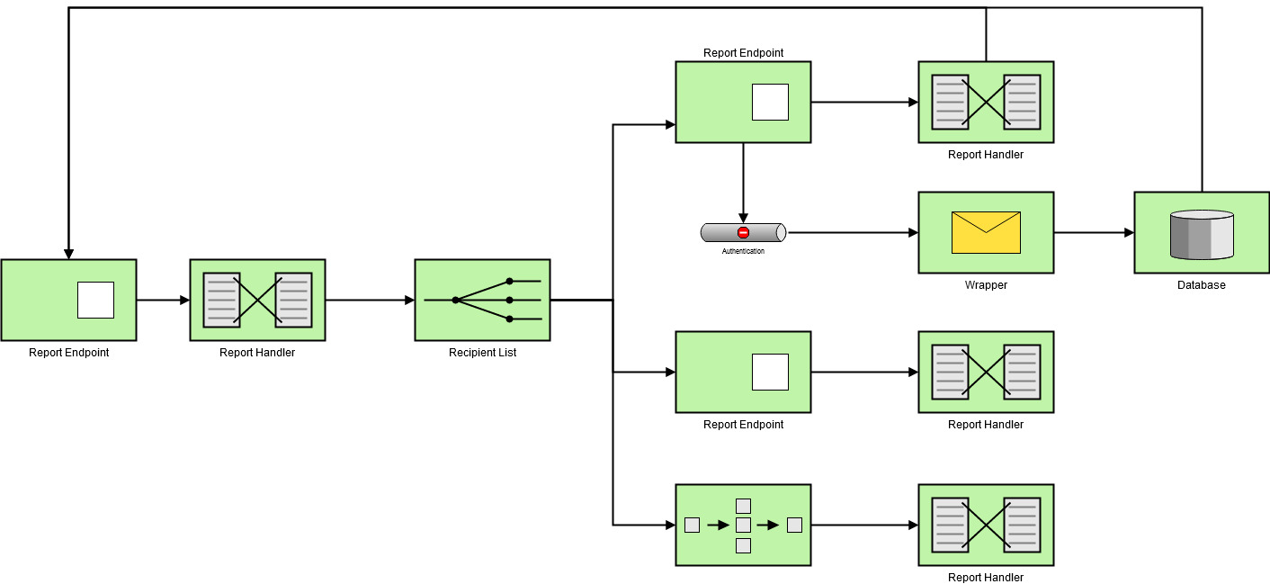

#### **3.3.2 Security**

The server on which the Outage Report resides will have its own security to prevent unauthorized *write*/*delete* access. There is no restriction on *read* access. The use of email by an Reporter or Vendor is on the client systems and thus is external to the system.

#### 